Announcing
THE NORTH U MATCH RACING CLINIC – CORINTHIAN YACHT CLUB
MARBLEHEAD, MA
May 18-20, 2018

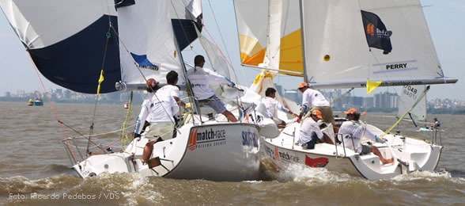

NOTICE OF CLINIC

This Clinic is designed to introduce sailors to the excitement, skills and tactics of match racing, and to raise the skill level of those who have experience in match racing. It is also an opportunity to learn and improve on the techniques needed to sail a small keelboat, including spinnaker use and sail trim.

The Clinic will be coached by Dave Perry, five-time U.S. National Match Racing champion and two-time Congressional Cup champion.

Dave will coach the tactics and strategies needed to be competitive and successful in match racing on the National level, including the Pre-Start, Upwind and Downwind Tactics, and Killing Penalties. On the water, Dave will run the sailors through all the scenarios, with on-the-spot feedback, and video replay after sailing. In addition, he will give much instruction and feedback on how to sail a keelboat fast and do all the boat handling needed to be successful.
Match racing skills are also very helpful in more advanced team and fleet racing where being able to control an opponent, and avoid being controlled yourself, can be race or series-winning skills.
Dave will also explain the significant new rule changes being used in match racing (see Appendix C of The Racing Rules of Sailing).

HOST: Corinthian Yacht Club, Marblehead MA

BOATS: The boats used will be Sonar’s.

TARGET SAILORS: The clinic is for sailors of all ages who are interested in learning more about match racing in small keelboats, and in raising their match racing and sailing skill level. No match racing or keelboat sailing experience is needed or expected and sailors/teams of all levels are welcomed and will learn a lot.

INDIVIDUALS OR TEAMS: Sailors can register as individuals or in teams of 3 or 4. There will be a cap on the number of participants. Registration will be on a first come-first served basis (with preference to sailors who sail in the Marblehead area until April 15, 2018) until the clinic is filled. Register as soon as possible.

TO REGISTER: Each participant (regardless of if you are registering as an individual or team) must individually register and pay by completing the following google form: Registration Form.

If you have formed a team for the clinic, please indicate this where asked on the form.

Payment is by cross charge for Corinthian, Boston and Eastern members by indicating your member number on the form. Others must mail a check, payable to Corinthian Yacht Club, to Joseph Fava, 87 Banks Road Swampscott, MA 01907. Entries will be confirmed upon receipt of payment.

Regardless of payment method, all participants must complete the google form and pay their clinic fee individually.

ENTRY FEE: The clinic fee is $75 per sailor, payable on registration. This includes the coaching, use of the boats, dinner on Friday and Saturday night, box lunch on Saturday and Sunday, Dave Perry’s Match Racing Playbook 4th edition and much more.

Damage deposit information: Each sailor who wishes to skipper at some point in the Clinic must provide a refundable damage deposit of $500, which will be done via credit card on registration or at the event.

SCHEDULE:
Friday, May 18: 3:00pm – 5:45pm – Optional on-water coaching for match racing boat handling and boat speed
6:15 – Dinner
7:00 - 9:30pm – Welcome to Match Racing (Pre-start tactics)
Saturday, May 19: 8:30am - 8:30pm………….. Clinic, Dinner & Video Debrief
Sunday, May 20: 8:30am - 5:00pm………….. Clinic, Racing & Wrap-Up

MEALS/WATER: Dinner Friday (Burgers/Hot dogs/Salad/Cash Bar) and Saturday evening (Pizza/Keg Beer) as well as box lunches on Saturday and Sunday are included in the entry fee. Participants are responsible for breakfast, and water bottles (refillable containers please – we will have jugs to refill on the water).

ACCOMMODATION: We will make every effort to provide housing for out of town sailors in members’ private homes. Please contact Joe Fava by May 1 if you will need housing.

For more information contact:

Joe Fava
joseph.c.fava@gmail.com
617.880.9807

